[Date]

[NAME]
{Address]
{City, State, Zip]

Dear [First name]:

On behalf of the Jewish Community Relations Council of NY, our officers and your fellow Board members, we would like to express our gratitude for your most generous donation on [Payment Date] for the annual Israel Parade.

Your support allows the parade participants and audience to enjoy this important annual tradition. In today’s complex and often challenging times, your gift strengthens our efforts to insure the enjoyment and security of our participants and attendees, who come from all over the tri-state New York City area, and beyond.

It is our pleasure to have you as part of the JCRC-NY family!

Sincerely,

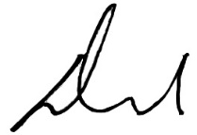 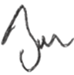 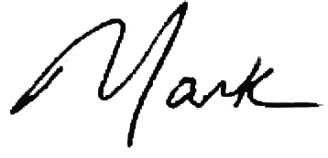
David L. Moore Bennett W. Golub Mark Treyger
President Chair of the Board CEO

